GOVERNMENT POLYTECHNIC,DHARMAVARAM
Department of Computer Engineering
GPT - 170, DMM
PROJECT WORK
Scheme: C-20 Subject code: CM-509


DEPARTMENT OF COMPUTER ENGINEERING

GPT, Dharmavaram-515672

2024-2025

A PROJECT REPORT ON

KEYSTROKE INJECTION MODULE USING ESP32

A PROJECT REPORT SUBMITTED IN PARTIAL FULFILLMENT OF THE REQUIERMENTS FOR THE AWARD OF THE DEGREE OF

DIPLOMA IN COMPUTER ENGINEERING

Submitted by
K. Karthik Reddy 22170-CM-026
A. Madan Lakshminadh 22170-CM-003
A. Ranjith 22170-CM-004
G. Lokesh 22170-CM-020
N. Venkateswarulu 22170-CM-034
S. MD. Sajeed 22170-CM-044
S. Anand 22170-CM-045

Sri. P.KIRAN KUMAR

Lecturer in Computer engineering



DIPLOMA IN COMPUTER ENGINEERING
GOVERNMENT POLYTECHNIC, DHARMAVARAM-515672
ANDHRA PRADESH

2024-2025

ACKNOWLEDGEMENT
In the name of almighty most beneficent and merciful, first of all I want to price the lord for helping me in all the stages of dissertation work.
We should also like to thank our guide P.KIRAN KUMAR for her valuable suggestions and constant encouragement.
We wish to express heartfelt and sincere gratitude to internal guide P. KIRAN KUMAR Lecturer in Computer Engineering in Government Polytechnic, Dharmavaram. For his excellent guidance and encouragement during the course of this dissertation work.
We would like to thank all the staff of Computer Engineering DIPLOMA in Government Polytechnic, Dharmavaram. For their help and cooperation during case of this Project.
K. Karthik Reddy 22170-CM-026
A. Madan Lakshminadh 22170-CM-003
A. Ranjith 22170-CM-004
G. Lokesh 22170-CM-020
N. Venkateswarulu 22170-CM-034
S. MD. Sajeed 22170-CM-044
S. Anand 22170-CM-045

KEYSROKE INJECTION MODULE USING ESP32
HID EMULATION DEVICE

TABLE OF CONTENTS
Content:

- Abstract

- Introduction
  - Objective
  - Scope
  - Problem Definition

- Project Oriented Model
  - Who uses the waterfall model?
  - Phases of the waterfall model

- System Architecture and Design
  - System Design
  - Schematic Diagram

- Estimation Cost
- Hardware Requirements
  - ESP32-S3 MINI (node MCU)
  - What is ESP32 S3 MINI (node MCU)?
  - Why is ESP32-S3 MINI (node MCU)?
  - Overview
  - Key Features
  - Applications of ESP32-S3 Mini
  - Technical Specs
  - Basic ESP32-S3 MINI (node MCU) code definition

- HUMAN INTERFACE DEVICE (HID)
  - What is Human Interface Device (HID)?
  - A Standard to Simplify Accessories
  - HID and Applications
  - Types of Human Interface Devices

8. USB C to USB A Male to Male ADAPTER

9. KALI LINUX
9.1 What is Kali Linux?
9.2 Features
9.3Tools and Software
9.4 Uses
9.5 System Requirements
9.6 Download and Installation
9.7 Conclusion

10. Powershell
10.1 What is windows powershell?
10.2 Why Use Windows PowerShell?
10.3 Key PowerShell Concepts
10.4 Common Use Cases of PowerShell
10.5 Overview
10.6 Benefits of Using PowerShell
10.7 Conclusion

11.ngrok
11.1 Overview
11.2 What is ngrok
11.3 Installation of ngrok
11.4 Running ngrok Persistently​

12. Arduino IDE
12.1 Introduction
12.2 Overview
12.3 Functions and Functionality

13. Final Program Block Code

14. Testing

15. Application

16. Features

17. Advantages

18. Disadvantages

19. Result & Analysis

20. Conclusion & Future Enhancements

KEYSTROKE INJECTION USING ESP32
1.ABSTRACT
Keystroke injection is a technique where a device simulates keyboard inputs to interact with a target system, often without the user’s knowledge. The ESP32 microcontroller, with its built-in Wi-Fi and Bluetooth capabilities, can be programmed to act as a keyboard, sending keystrokes to a computer or other devices. By either using a USB OTG cable or Bluetooth Low Energy (BLE), the ESP32 can emulate a keyboard and inject keystrokes, which can be used for tasks such as automation or penetration testing.
This method has various applications in security and automation, allowing users to automate repetitive tasks or perform testing on devices. However, it also raises security concerns, as it can be used maliciously to control systems without authorization. Understanding how the ESP32 can be used for keystroke injection is important for developers looking to utilize it for legitimate purposes and security professionals working to defend against unauthorized use.

K. Karthik Reddy 22170-CM-026
A. Madan Lakshminadh 22170-CM-003
A. Ranjith 22170-CM-004
G. Lokesh 22170-CM-020
N. Venkateswarulu 22170-CM-034
S.MD.Sajeed 22170-CM-044
S. Anand 22170-CM-045

SIGNATURE OF GUIDE SIGNATURE OF HOD

P. KIRAN KUMAR,_{M. Tech}.
L/CM
2. INTRODUCTION
2.1 Objective:
keystroke injection system using the ESP32 microcontroller, enabling the device to emulate a USB keyboard and send pre-programmed keystrokes to a target computer or system. The system will use the ESP32's USB Host or Bluetooth capabilities to inject keypresses for various applications such as automation, security testing, or educational purposes. The project will focus on configuring the ESP32 to function as a HID (Human Interface Device), implementing software to program the desired keystrokes, and testing the system's functionality in real-world environments.

To develop and implement a keystroke injection system using the ESP32 microcontroller, enabling the device to emulate a USB keyboard and send pre-programmed keystrokes to a target computer or system. The system will use the ESP32's USB Host or Bluetooth capabilities to inject keypresses for various applications such as automation, security testing, or educational purposes. The project will focus on configuring the ESP32 to function as a HID (Human Interface Device), implementing software to program the desired keystrokes, and testing the system's functionality in real-world environments.

In simply, Keystroke injection using an ESP32 is typically used for a variety of purposes related to automation, security testing, and creating clustom input devices.

2.2 Scope:
1. Research and Development: Study keystroke injection techniques and their impact on device security.
Explore the capabilities of the ESP32 module for simulating keyboard keystrokes and wireless communication.
Design and develop a functional keystroke injection system that can demonstrate security risks.

2. Implementation and Testing: Develop a prototype that can wirelessly transmit keystrokes to a target device.
Test the system on multiple devices (PCs, laptops, mobile devices) to evaluate its effectiveness and stealth capabilities.
Analyze system performance, including response time, detection avoidance, and reliability.

3. Security Evaluation and Mitigation Strategies: Assess the feasibility and impact of keystroke injection attacks on modern security systems.
Identify potential vulnerabilities in current device security mechanisms.

Explore countermeasures such as encryption, secure authentication, and intrusion detection to mitigate keystroke injection threats.

4. Ethical and Legal Considerations: Ensure the project follows ethical hacking guidelines and is used for educational and research purposes only.
Review legal implications of keystroke injection and responsible disclosure of security vulnerabilities.

5. Future Applications and Research Opportunities: Investigate potential applications in penetration testing and cybersecurity research.
Suggest improvements and further research directions for enhancing device security.

2.3 Problem Definition:

The keystroke injection system will utilize the ESP32 module's processing power and communication capabilities to simulate keyboard keystrokes and transmit them wirelessly to a target device. The system will be designed to operate stealthily, avoiding detection by the target device or its user. By developing this system, we aim to highlight the potential security risks of keystroke injection attacks and encourage the development of more secure devices.

To ensure the effectiveness of the keystroke injection system, we will conduct thorough testing and evaluation. This will involve testing the system against various devices, including computers, laptops, and mobile devices. We will also evaluate the system's ability to operate stealthily and avoid detection. The results of this testing and evaluation will provide valuable insights into the feasibility and potential impact of keystroke injection attacks.

The keystroke injection project has significant implications for device security. By demonstrating the potential risks of keystroke injection attacks, we hope to encourage device manufacturers to implement more secure designs and protocols. This could include the use of encryption, secure communication protocols, and intrusion detection systems. Ultimately, our goal is to contribute to the development of more secure devices that are better equipped to withstand keystroke injection attacks.

Its implications for device security, the keystroke injection project also has potential applications in fields such as penetration testing and security research. By developing a keystroke injection system, we can provide security professionals with a valuable tool for testing device security and identifying potential vulnerabilities. This could help to identify and address security risks before they can be exploited by malicious actors.

3.PROJECT OVERVIEW MODEL

In a practical software development project, the classical waterfall is hard to use.so, the Iterative water fall model can be thought incorporating the necessary changes to the classical waterfall model to make it usable in practical software development projects. It is almost the same as the classical waterfall model except some changes are made to increase the efficiency of the software development. The iterative waterfall model provides feedback paths from every phase to its preceding phases, which is the main difference from the classical waterfall model.
Feedback paths introduced by the iterative waterfall model are shown in the figure below.
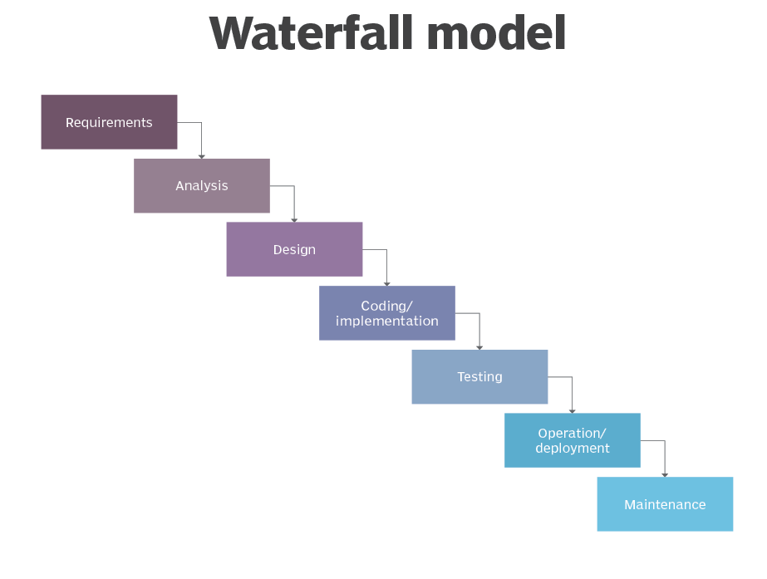
3.1 Who use the waterfall model?

Project teams and project managers use the Waterfall model to achieve goals based on the needs of their business. The model is used in many different project management contexts, such as in construction, manufacturing, IT and software development.

In the Waterfall methodology, each step is dependent on the output of the previous step. There's a linear progression to the way these projects unfold.

For example, in construction, these three general steps are usually followed:

- A building's physical design is created before any construction begins.
- The foundation is poured before the skeleton of a building is erected.
- The skeleton of the building is completed before the walls are built.

On a manufacturing line, steps are followed sequentially in a controlled order when building a product until the finished deliverable is created.

The Waterfall model doesn't include a project's end users or clients as much as other development methodologies. Users are consulted during the initial stages of gathering and defining requirements, and client feedback is incorporated after that. By leaving the client out of the main part of the Waterfall process, the development team moves quickly through the phases of a project.

This methodology is good for teams and projects that want to develop a project according to fixed or unchanging requirements set forth at the beginning of the project. Waterfall projects have a high degree of process definition with little or no output variability. Waterfall is also a good choice if the project has cost or time constraints.

Projects based on the Waterfall method are well defined, are predictable and have specific documentation. They have the following characteristics:

- fixed requirements,
- ample resources,
- well-understood technology and
- un likely to require significant changes.
In software development processes, if an application must work out of the box immediately at the risk of losing customers or some other serious issue, Waterfall is a suitable method. Contrast that with the Agile project management and development model. Agile methods use ongoing reiteration. Its iterative approach involves designing, developing and testing software in repeated cycles that build upon each other.

3.2 Phases of the Waterfall model
When used for complex projects, such as software development, the Waterfall development methodology has seven stages:

Requirements:Potentialproject requirements, deadlines and guidelines for the project are analysed and placed into a formal requirements document, also called a functional specification. This first phase of development defines and plans the project without mentioning specific processes.

Analysis: The system specifications are analysed to generate product models and business logic to guide production. This is also when financial and technical resources are audited for feasibility.

Design: A design specification document is created to outline technical requirements during the design phase. These include the programming language, hardware, data sources, architecture and services.
Coding and implementation: The source code is developed using the models, logic and requirement specifications designated in the previous phases.
Testing: This is when quality assurance and unit, system and beta tests identify issues that must be resolved. This forces a repeat of the coding stage for debugging. If the system passes integration and testing, the Waterfall process continues forward.

Operation and deployment: The product or application is deemed fully functional and is deployed to a live environment.

Maintenance: Corrective, adaptive and perfective maintenance is carried out indefinitely to improve, update and enhance the product and its functionality. This could include releasing patch updates and new versions.

4.SYSTEM ARCHITECTURE AND DESIGN

4.1System design:
BUTTON INPUT
ESP32 S3 MINI

KEYS INJECTIONS
4.2Schematic Diagram:
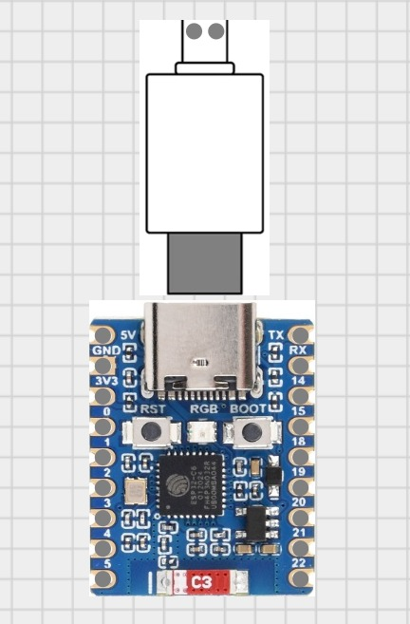

5.ESTIMATION COST

- ESP32 S3 MIN: 700 INR
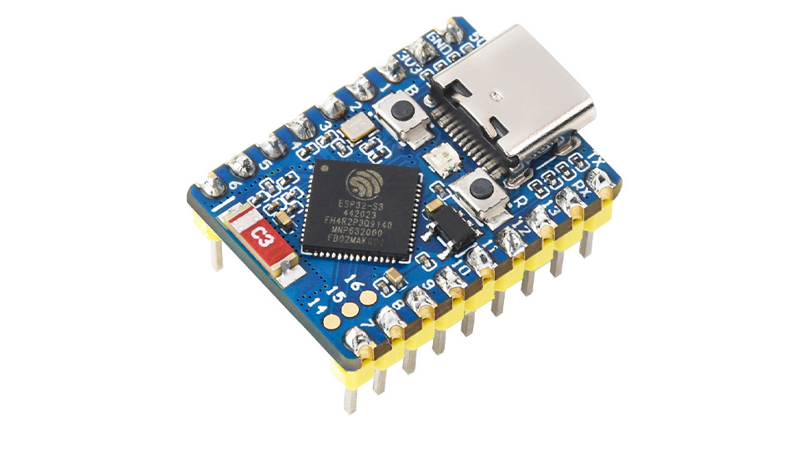

- Adapter: 100 INR
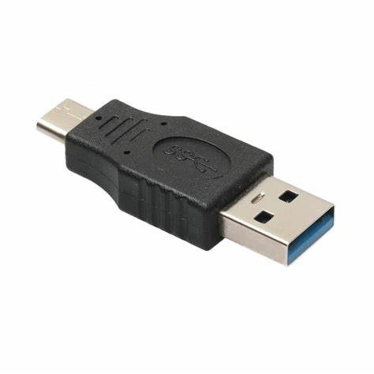

6.HARDWARE REQUIREMENTS

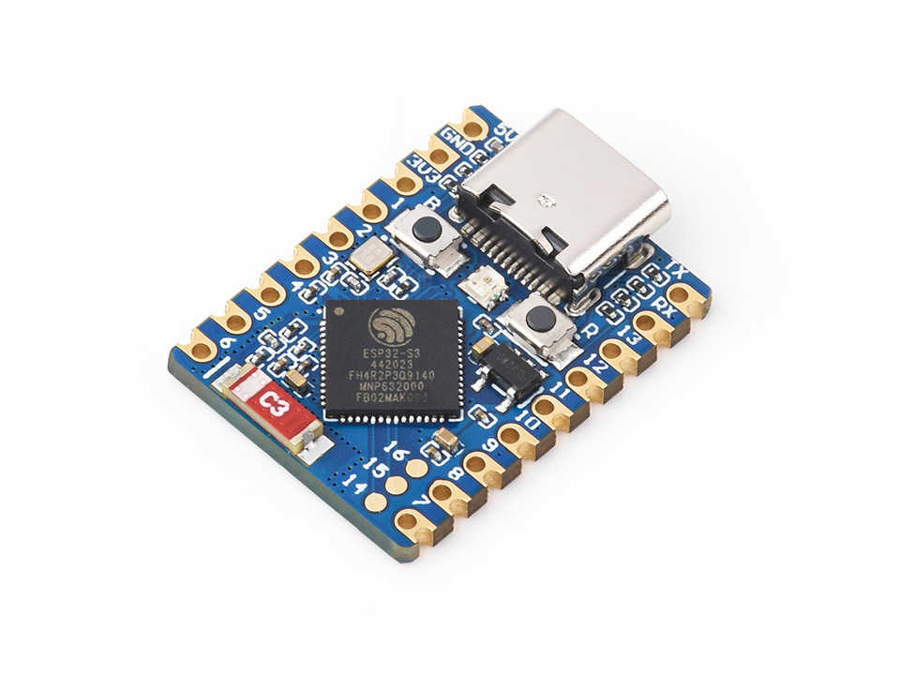
6.1. 1.ESP32-S3 MINI(node MCU)

6.2 What is ESP32-S3 MINI (node MCU)?

The ESP32-S3 MINI is a microcontroller board based on the ESP32-S3 chip, which is a powerful and feature-rich IoT platform.
It is designed for IoT, embedded systems, and AI applications while offering a balance ofperformances,power efficiency, and connectivity.
One of the interesting projects that can be done with the ESP32-S3 MINI is keystroke injection.

6.3 Why is ESP32-S3 MINI(node MCU)?

The ESP32-S3 Mini is important because it offers a powerful, compact, and versatile microcontroller with integrated Wi-Fi and Bluetooth LE capabilities, making it ideal for a wide range of IoT applications where small size, low power consumption, and wireless connectivity are crucial, including smart home devices, wearables, industrial sensors, and more, all while maintaining a relatively easy development process with a rich set of peripherals and compatibility with popular development environments like Arduino IDE and ESP-IDF.

6.4 Overview
The ESP32-S3 MINI module is a communication module that facilitates GSM (Global System for Mobile Communications) connectivity for electronic devices. This module is commonly used in embedded systems and IoT (Internet of Things) application to enable communication.

6.5Key Features:

Compact size:Its small footprint allows for integration into tight spaces, making it suitable for miniaturized devices.

Dual-core processor:The ESP32-S3 chip has a powerful dual-core processor, enabling efficient handling of complex tasks and faster processing speeds.

Wi-Fi and Bluetooth connectivity:Built-in support for both 2.4GHz Wi-Fi and Bluetooth Low Energy (BLE) allows for seamless wireless communication with other devices.
Low power consumption:Designed for battery-powered applications with power-saving features to extend battery life.

Extensive I/O pins:Offers a large number of GPIO pins for interfacing with various sensors and actuators.

Development ease:Compatible with the widely used ESP-IDF framework and Arduino IDE, making it easier for developers to program and prototype.

Security features: Supports robust security mechanisms like AES encryption and secure boot for enhanced data protection.

6.6 Applications of ESP32-S3 Mini:
Wearable electronics: Fitness trackers, smartwatches, and health monitoring devices.
Smart home devices: Smart switches, sensors, door locks, and other connected home appliances.
Industrial automation: Remote monitoring and control of industrial sensors and actuators.

6.7 Technical Specs

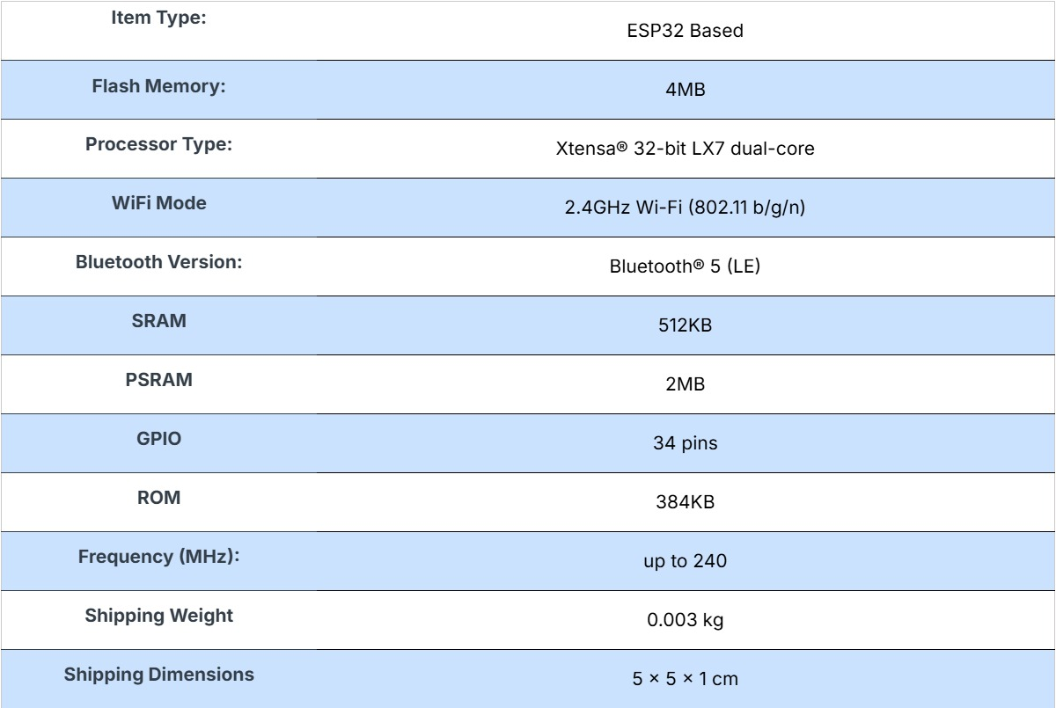
6.8 Basic ESP32-S3 MINI (node MCU) code definition

Setup(): A function present in every ESP32-S3 MINI sketch. Run once before the loop() function. Often used to set pinmode to input or output.
The setup() function looks like:
void setup()
{
//code goes here
}
Loop(): A function present in every single ESP32-S3 MINI sketch. The code happens over and over again. The loop() is where (almost) everything happens. The one exception to this setup() and variable declaration. ModeKit uses another type of loop called “forever()” which executes over serial.
The loop() function looks like:
void loop()
{
//code goes here
}

Input: A pin mode that intakes information.
Output: A pin mode that sends the information.
HIGH: Electrical signal present (5v for RSP32). Also ON True in boolean logic.
LOW: No electrical signal present (0v). Also OFF or False in boolean logic.
DigitalRead: Get a HIGH or LOW reading from a pi already declared as an input.
digitalWrite: Assign a HIGH or LOW value to a pin already declared as an output.
analogRead: Get a value between or including 0 (LOW) and 1023 (HIGH). This allows you to get readings from analog sensors or interfaces that have morethan two states.
analogWrite: Assign a value between or including 0 (LOW) and 255 (HIGH). This allows you to set output to a PWM value instead of just HIGH or LOW.
PWM: Stands for Pulse-Width Modulation, a method of emulating an analog signal through a digital pin. A value between or including 0 and 255. Used with analogWrite.

7. HUMAN INTERFACE DEVICE (HID)

7.1 what is Human Interface Device (HID)?

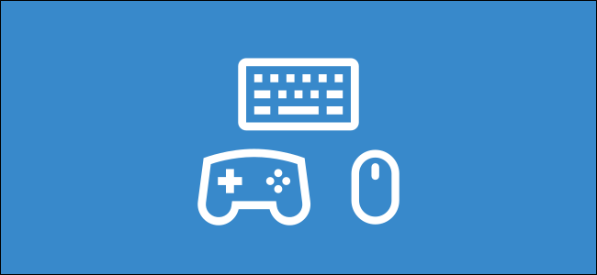
There are a lot of strange terms that come with using a computer. One that you may have seen is "Human Interface Device" or "HID." It sounds like something out of a sci-fi movie, but what exactly does it mean?
"Human Interface Device" may sound strangely alien, but the name is actually very descriptive. Simply put, an HID is a standard for computer devices that are operated by humans. The standard allows these devices to be easily used without any extra software or drivers.

7.2 A Standard to Simplify Accessories

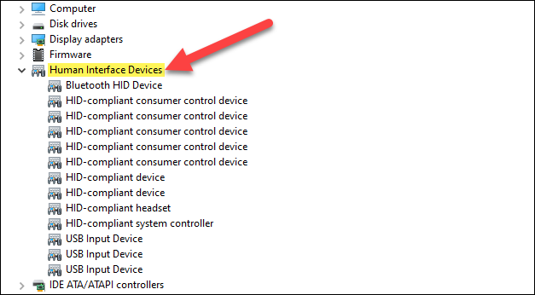
HID in the Windows Device Manager
"Human Interface Devices" is a standard that was created to simplify the process of installing input devices. Prior to HID, there were several specific protocols for each type of input device.
That meant there was a protocol for mice, a protocol for keyboards, and so on. Devices needed to use the existing protocols or create custom drivers. People had more work to do when installing and configuring devices.
In comparison, an HID-compliant device includes "data packets" that contain all the actions of the device. For example, a keyboard might have a key for adjusting volume. When that key is pressed, the "HID descriptor" tells the computer where the purpose of that action is stored in the packets, and it's executed.
The HID protocol makes it much easier for companies to produce widely compatible accessories. All modern operating systems support the HID protocol. You can plug a USB keyboard into a Windows PC, Mac, Chromebook, or even an Android tablet, and it will be functional immediately. That's all thanks to HID.

7.3 HID and Applications

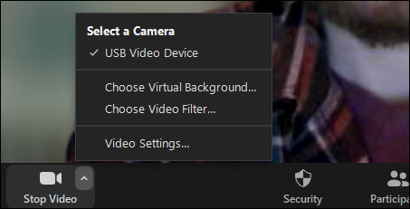

The biggest advantage of HID is being able to simply connect almost any peripheral to your device and have it start working immediately. That's only half of the magic, though.
What about making sure these accessories works with apps?
You can plug a USB controller into your PC and it will usually control the game as it should. Even if the controller was made after the game, it still works. The game developers didn't have to do anything to make that happen.
When you connect an HID device, it announces its capabilities to the operating system. The operating system interprets the data and classifies the device. This allows apps and games to target classes of devices rather than specific models.
This is a super important element of HID, and it's something we take for granted. A gaming controller will work with your Steam library. Zoom will know to turn on your webcam. All of this happens with very little setup on your end.

7.4 Types of Human Interface Devices
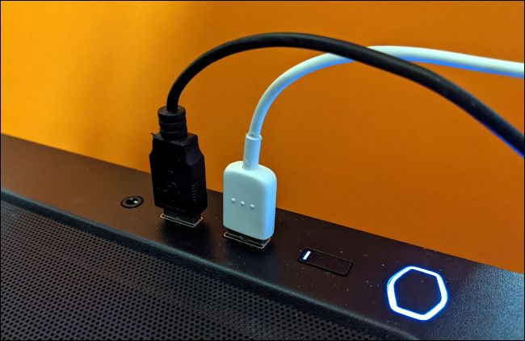

As previously mentioned, USB peripherals are the most common human interface devices you'll see, but there are other types.
USB devices fall into the "USB-HID" class. That includes common things like keyboards, mice, webcams, track pads, and gaming controllers. Other USB-HID devices include thermometers, audio instruments, and medical equipment, phones, and exercise machines.
The other common type is Bluetooth-HID. It's the same USB-HID protocol with some slight modifications for Bluetooth. As you might expect, this includes similar devices to USB-HID, but they connect over Bluetooth. A Bluetooth mouse will simply work whether connected to a Windows PC, Mac, or Chromebook.

Human Interface Devices are some of the most common devices that we use with computers. We don't truly appreciate how easy they are to use. There was a time when it wasn't so simple.
Not only is HID responsible for making computers easier to use, but it has also contributed to the massive market for accessories. There are thousands of keyboards, mice, webcams, controllers, and other products that you simply don't have to worry about not being compatible with your computer.
There have been much advancement in the history of computers, but the Human Interface Device standard is one that has been a smashing success.

- USB C to USB A Male to Male ADAPTER
8.1 Overview
A USB-C to USB-A Male-to-Male Adapter is a device that allows two USB-A ports (commonly found on older devices) to be connected using a USB-C cable. The adapter features two male connectors: one USB-C and one USB-A, allowing the connection of USB-C compatible devices (like newer smartphones, laptops, and tablets) to USB-A devices (such as older computers, printers, or external hard drives).
8.2 Purpose of Adapter
A USB-C to USB-A Male-to-Male Adapter allows you to connect devices with a USB-C port to a device with a USB-A port using a short cable or adapter. Typically, these adapters are used when you want to connect a modern device with a USB-C port (like a newer laptop, smartphone, or tablet) to a device that only has a USB-A port, such as older laptops, desktop computers, or peripherals.

8.3 Features:
- Connector Types:
  - USB-C Male: Plugs into devices with USB-C ports (e.g., modern laptops, phones, and tablets).
  - USB-A Male: Plugs into USB-A ports (commonly found on desktops, older laptops, and many peripherals).
- Use Case:
  - This adapter is used to connect devices that have USB-A ports to devices that use USB-C. For instance, you could use this adapter to transfer data between an older computer (USB-A port) and a newer device (USB-C port).
- Data Transfer:
  - The adapter allows data to be transferred between devices, but the speed of transfer depends on the specific USB versions supported by both devices (e.g., USB 3.0, USB 2.0).
- Power Delivery:
  - While the primary purpose of such an adapter is often data transfer, some adapters may support power delivery, enabling charging between devices, though USB-C to USB-A charging is generally slower and not ideal for high-power devices.
- Size and Portability:
  - USB-C to USB-A Male-to-Male adapters are typically compact and easy to carry, making them convenient for users needing to bridge the gap between different USB standards.
- Compatibility:
  - Most adapters are backward compatible with USB 2.0 and USB 3.0 standards, but performance may be limited to the slower USB-A standard if the devices do not support higher speeds.

8.4 Common Uses:
- Connecting a USB-C device (like a new laptop) to an older USB-A device (such as an external hard drive).
- Using USB-A accessories (like a keyboard or mouse) with a newer laptop or tablet that only has USB-C ports.

8.5 Limitations:
- One-way directionality: Often, these adapters are designed to work in only one direction (from USB-C to USB-A or vice versa), so it’s important to check the adapter’s specifications.
- Speed limitations: USB-A is older and may not support the high data transfer speeds of USB 3.1 or USB 3.2 standards found in USB-C devices.
- Limited Charging: While power delivery might be supported, USB-C to USB-A adapters are not ideal for charging devices that require significant power.

8.6 Conclusion:
A USB-C to USB-A Male-to-Male Adapter is useful for those who need to connect or transfer data between older USB-A devices and modern USB-C devices. It’s a simple and affordable solution for backward compatibility, although there are limitations in terms of speed and power delivery.

9. KALI LINUX

9.1 What is Kali Linux?
Kali Linux is a Debian-based Linux distribution designed for digital forensics, penetration testing, and ethical hacking.

9.2 Features
1. Open-source: Kali Linux is free and open-source.
2. Customizable: Kali Linux can be customized to meet specific needs.
3. Large toolset: Kali Linux comes with over 600 pre-installed tools for penetration testing and digital forensics.
4. Support for multiple platforms: Kali Linux supports multiple platforms, including x86, x86_64, ARM, and ARM64.
5. Live boot: Kali Linux can be booted from a USB drive or CD/DVD, allowing for a portable and non-intrusive installation.

9.3 Tools and Software

1. Nmap: A network scanning and exploration tool.
2. Metasploit: A penetration testing framework.
3. Burp Suite: A web application security testing tool.
4. Wireshark: A network protocol analyzer.
5. John the Ripper: A password cracking tool.

9.4 Uses
1. Penetration testing: Kali Linux is widely used for penetration testing and vulnerability assessment.
2. Digital forensics: Kali Linux is used for digital forensics and incident response.
3. Ethical hacking: Kali Linux is used by ethical hackers to test and improve the security of computer systems.
4. Security research: Kali Linux is used by security researchers to test and analyze new vulnerabilities.

9.5 System Requirements
1. CPU: 1.5 GHz or faster processor
2. RAM: 2 GB or more
3. Disk space: 20 GB or more
4. Graphics: 1024x768 or higher resolution

9.6 Download and Installation
Steps for installing Kali Linux
- Download the Kali Linux ISO image

- Burn the ISO to a DVD or image it to a USB drive

- Back up important information to an external media

- Set your computer to boot from the DVD, USB, or CD

- Disable Secure Boot in your UEFI settings

- Boot from the installation media

- Select Graphical Install or Install (Text-Mode)

- Choose a language, location, and keyboard orientation

- Configure your network, domain name, and users and passwords

- Partition your disks

- Install the GRUB boot loader

- Finish the installation

- Reboot and log in to Kali Linux

9.7 Conclusion
Kali Linux is a powerful and versatile Linux distribution designed for digital forensics, penetration testing, and ethical hacking. Its large toolset and customizable nature make it a popular choice among security professionals and researchers.

10. Powershell
10.1 What is Windows PowerShell?
Windows PowerShell is an object-oriented scripting language and command-line shell built on the .NET framework. It allows users to interact with the operating system (OS) and perform a variety of administrative tasks such as automation, system management, and network monitoring.

PowerShell is more than just a shell, it is a full-fledged automation framework. Unlike traditional command-line interfaces, which primarily work with text, PowerShell handles objects, enabling more complex data manipulation and automation tasks. This gives system administrators and developers greater control over their environment and the ability to automate tasks at scale.

10.2Why Use Windows PowerShell?
Automation: Automate repetitive tasks, such as creating user accounts, configuring network settings, or deploying software.
Remote Management: Manage multiple systems remotely, execute commands on distant machines, and automate administrative tasks.
System Administration: Perform advanced system administration tasks, including troubleshooting, security configuration, and performance tuning.
Scripting: Create custom scripts to streamline workflows and solve complex problems.
Integration with .NET: Leverage the vast .NET ecosystem to extend PowerShell's capabilities and build sophisticated tools.

10.3Key PowerShell Concepts
Cmdlets: Pre-built commands that perform specific actions, such as Get-Process, Start-Service, and Remove-Item.
Pipelines: Chain cmdlets together to create complex operations.
Scripting: Write scripts using PowerShell's scripting language to automate tasks.
Modules: Reusable collections of cmdlets, functions, and variables.
Providers: Extend PowerShell's file system navigation capabilities to work with various data sources, such as registry, WMI, and Active Directory.

10.4Common Use Cases of PowerShell

1. System Administration
PowerShell simplifies the management of Windows servers, Active Directory, and network devices. Administrators can automate tasks like:

User account creation and management
Server configuration and patch management
File system management (e.g., backups, directory structure)
Example: This command creates a new user in Active Directory.

New-ADUser -Name "John Doe" -SamAccountName "jdoe" -UserPrincipalName "jdoe@domain.com" -Path "OU=Users,DC=domain,DC=com"

2. Cloud Management
PowerShell is integral to Azure management and other cloud platforms. With PowerShell cmdlets for Azure, you can automate the deployment of resources, manage storage accounts, and scale virtual machines.

3. Task Scheduling and Automation
By leveraging the Windows Task Scheduler and PowerShell scripts, IT professionals can automate maintenance tasks, such as server health checks or software updates, on a daily, weekly, or monthly basis.

4. Network Configuration
You can use PowerShell to manage and automate network settings, such as IP address configurations, network interfaces, and firewall rules. For instance, configuring a static IP address on a machine can be done quickly with a simple script.

Example:
New-NetIPAddress -InterfaceAlias "Ethernet" -IPAddress "192.168.1.100" -PrefixLength 24 -DefaultGateway "192.168.1.1"

5. Data Retrieval and Parsing
PowerShell allows the retrieval and parsing of data from multiple sources such as files, databases, or APIs. This is especially useful for generating reports, auditing system states, or gathering performance metrics.

6. Security and Compliance
PowerShell scripts can be used to audit system configurations and ensure compliance with internal or external security policies. For example, you can check whether all security patches are up to date, or verify that user permissions are correctly configured.

Getting Started with PowerShell
Step 1: Open PowerShell:
Search for "PowerShell" in the Start menu and open it.

Basic PowerShell Commands List
Get-Help: Displays help information for cmdlets.
Get-Command: Lists available cmdlets.
Get-Process: Lists running processes.
Stop-Process: Stops a running process.
Get-Service: Lists running services.
Start-Service: Starts a service.
Stop-Service: Stops a service.

10.5 Overview
Scripting: Use PowerShell's scripting language to write complex scripts that automate tasks.
Remote PowerShell: Manage remote computers using PowerShell remoting.
PowerShell Modules: Create custom modules to extend PowerShell's functionality.
PowerShell Profiles: Customize your PowerShell environment with profiles.
PowerShell Workflow: Build long-running, multi-step processes.
PowerShell Desired State Configuration (DSC): Define and enforce system configurations.

10.6Benefits of Using PowerShell
1. Enhanced Productivity
By automating repetitive tasks and providing access to advanced system management tools, PowerShell can dramatically improve productivity. Tasks that would traditionally take hours can now be completed in minutes.

2. Scalability
With PowerShell, administrators can easily scale their processes, whether managing a few machines or thousands. PowerShell scripts can be run across multiple systems simultaneously, significantly reducing manual intervention.

3. Ease of Learning
For users familiar with command-line interfaces, PowerShell is relatively easy to learn. Its use of clear syntax, object manipulation, and rich documentation makes it accessible to beginners, while still powerful for experienced users.

4. Powerful Remoting and Administration Tools
PowerShell's remote capabilities allow sysadmins to manage systems across an entire enterprise without needing to physically access each device.

10.7Conclusion
Windows PowerShell is more than just a tool—it's an essential component of system administration, cloud management, and software development in the Windows ecosystem. With its powerful cmdlets, object-oriented nature, automation capabilities, and remote management features, PowerShell has solidified its place as one of the most adaptable command-line environments available today.

11.ngrok

11.1 Overview
ngrok is your app's front door. ngrok is a globally distributed reverse proxy that secures, protects and accelerates your applications and network services, no matter where you run them. ngrok supports delivering HTTP, TLS or TCP-based applications.

11.2 What is ngrok?
ngrok is a globally distributed reverse proxy that secures, protects and accelerates your applications and network services, no matter where you run them. You can think of ngrok as the front door to your applications.

11.3 Installation of ngrok

Step 1: Install
curl -sSL https://ngrok-agent.s3.amazonaws.com/ngrok.asc \
| sudo tee /etc/apt/trusted.gpg.d/ngrok.asc >/dev/null \
&& echo "deb https://ngrok-agent.s3.amazonaws.com buster main" \
| sudo tee /etc/apt/sources.list.d/ngrok.list \
&& sudo apt update \
&& sudo apt install ngrok

Or download the ngrok agent from our Download page if you can't use one of the options above.

Going to the Setup & Installation page in the dashboard will also provide installation directions and commands specific to your platform.

The ngrok agent is a zero-dependency CLI program that runs on all major operating systems. Test that you installed it correctly by running the following command in your terminal and confirm that ngrok prints its help text.

ngrok help

Step 2: Connect your account
Next, connect your ngrok agent to your ngrok account. If you haven't already, sign up for an ngrok account. Copy your ngrok authtoken from your ngrok dashboard.

Run the following command in your terminal to install the authtoken and connect the ngrok agent to your account.

ngrok config add-authtoken <TOKEN>

Going to the Setup & Installation page in the dashboard will also provide a configuration command specific to your account.

Step 3: Put your app online​
Start ngrok by running the following command.

ngrok http http://localhost:8080

We're assuming that you have a working web application listening on http://localhost:8080. If your app is listening on a different URL, change the above command to match.
You will see something similar to the following console UI in your terminal.
ngrok (Ctrl+C to quit)

Session Status online
Account inconshreveable (Plan: Free)
Version 3.0.0
Region United States (us)
Latency 78ms
Web Interface http://127.0.0.1:4040
Forwarding https://84c5df474.ngrok-free.dev -> http://localhost:8080

Connections ttl opn rt1 rt5 p50 p90
0 0 0.00 0.00 0.00 0.00

Open the Forwarding URL in your browser and you will see your web application.
- This URL is available to anyone on the internet. Test it out by sending it to a friend!
- Your app is available over HTTPS with a valid certificate that ngrok automatically manages for you.
Step 4: Always use the same domain
If you want to keep the same URL each time you use ngrok, create a static domain on your dashboard and then use the --url flag to ask the ngrok agent to use it. First, stop ngrok with Ctrl+C and then run ngrok again:

ngrok http 8080 --url https://jumpy-red-mollusk.ngrok-free.app

Step 5: Secure your app
You may not want everyone to be able to access your application. ngrok can quickly add authentication to your app without any changes. If your Google account is alan@example.com, you can restrict access only for yourself by running ngrok with:

ngrok http http://localhost:8080 --oauth google --oauth-allow-email alan@example.com

Anyone accessing your app will be prompted to log in with Google and only your account will be allowed to access it. Keep in mind that when you restart ngrok, if you don't specify the --url flag that your app's URL changed, so make sure to visit the new one.

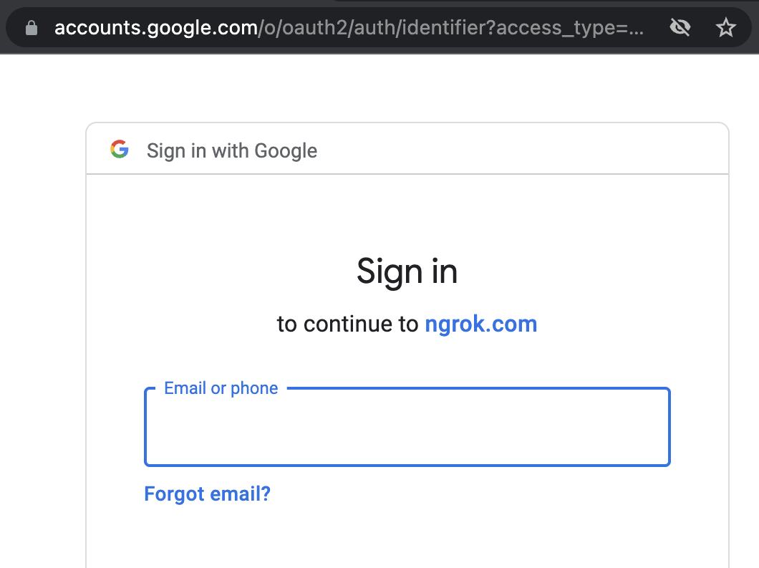
If you don't have a Google account or you want a simpler form of auth, you can protect your app with a username and password like so:

ngrok http http://localhost:8080 --basic-auth 'username:a-very-secure-password'
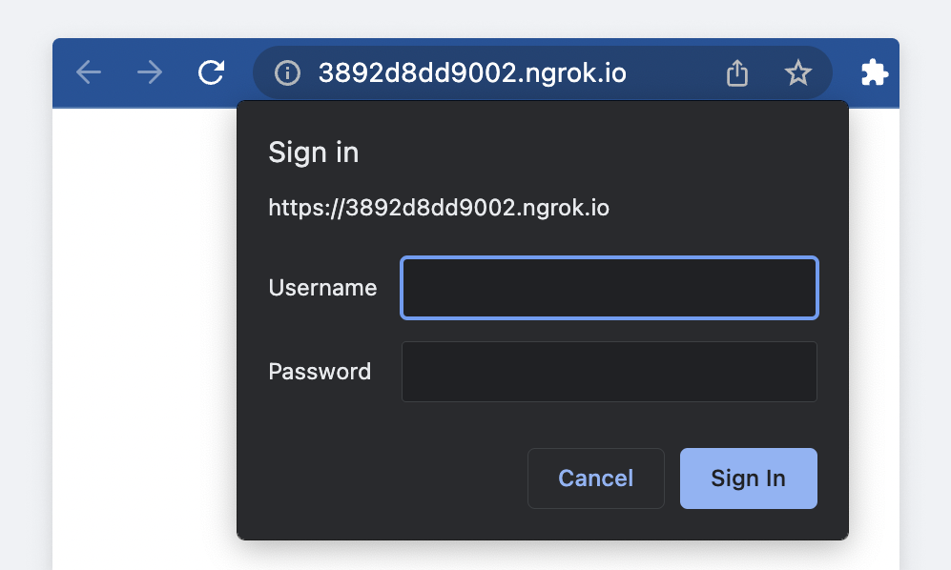
ngrok supports many forms of authentication including:
- OAuth (what we just used)
- Basic Auth (what we just used)
- IP Restrictions
- Webhook Verification
- Mutual TLS
- OpenID Connect
- JWT Validation
- SAML

11.4 Running ngrok Persistently​

While this guide gets you started with ngrok, you might want your tunnel to keep running even after you close your terminal window. Here are a few options to achieve this:
- Using Docker: Docker allows you to containerize ngrok for easy deployment and management. See the documentation for Docker configuration.
- Systemd service (Linux): For systemd-based systems, you can create a systemd service to automatically start and manage ngrok. Refer to the documentation for Systemd service creation.
- Windows service (Windows): For Windows systems, you can create a Windows service to automatically start and manage ngrok. Refer to the documentation for Background Service.
- Detaching a Tmux session (optional): If you're familiar with Tmux, you can detach your ngrok session from your terminal window.

12. ARDUINO IDE

The Arduino Integrated Development Environment (IDE) is the primary software used for programming Arduino boards.

12.1 Introduction

The Arduino IDE is an open-source software application designed to simplify the process of writing, compiling, and uploading code to Arduino compatible microcontroller boards.

12.2 Overview

This detailed overview of the Arduino IDE covers its functionality, features, board management, code compilation, customization options, and extensions, providing a comprehensive understanding of its capabilities for programming Arduino boards.

12.3 Features and Functionality:

- Code Editor: Provides a text editor for writing and editing code in the Arduino programming language (based on wiring).

- Compiler: Translates the written code into machine-readable instructions (binary code) that the Arduino board can understand.

- Uploader: Facilitates the transfer of compiled code from the computer to the Arduino board for execution.

- Syntax Highlighting: Highlights keyword, variables, and comments for easier code comprehension.

- Auto-Completion: Assists in completing code statements based on context.
- Code Folding: Allows collapsing sections of code for better organization.

- Library Manager: Provides access to a vast collection of pre-written code libraries for various sensors, actuators, and modules.

- Example Sketches: Offers numerous example codes demonstrating different functionalities to aid beginners.

- Debugging: Displays messages, sensor readings, or debug information from the Arduino board for real-time monitoring.

- Data Exchange: Allows communication between the Arduino board and the computer through serial communication.

- Board Manager: Allows selection of the specific Arduino board model and its specifications.

- Compatibility: Supports various Arduino boards and derivatives.

- Port Configuration: Identifies the communication port to which the Arduino board is connected on the computer.

- Auto-Detection: Automatically detects available ports for easy selection.

- Code Verification: Checks the code for syntax errors and compiles it into machine-readable instructions.

- Error Handling: Alerts users about compilation errors for debugging.

- Bootable Communication: Transfer compiled code to the Arduino board via the bootloader.

- Programming Sequence: Initiates the programming sequence to write the code to the board’s memory.

- Configuration Settings: Allows customization of settings such as language, editor themes, and font sizes.

- Compiler Settings: advanced setting for compiler optimization and debugging options.

- Plugins: Allows integration of third-party libraries and tools to enhance functionality.

- Debugging Tools: Extension for advanced debugging, profiling, and code analysis.

13. Web Server

13.1 What is Web Server?
A web server is a software application or hardware device that stores, processes, and serves web content to users over the internet. It plays a critical role in the client-server model of the World Wide Web, where clients (typically web browsers) request web pages and resources, and servers respond to these requests by delivering the requested content.

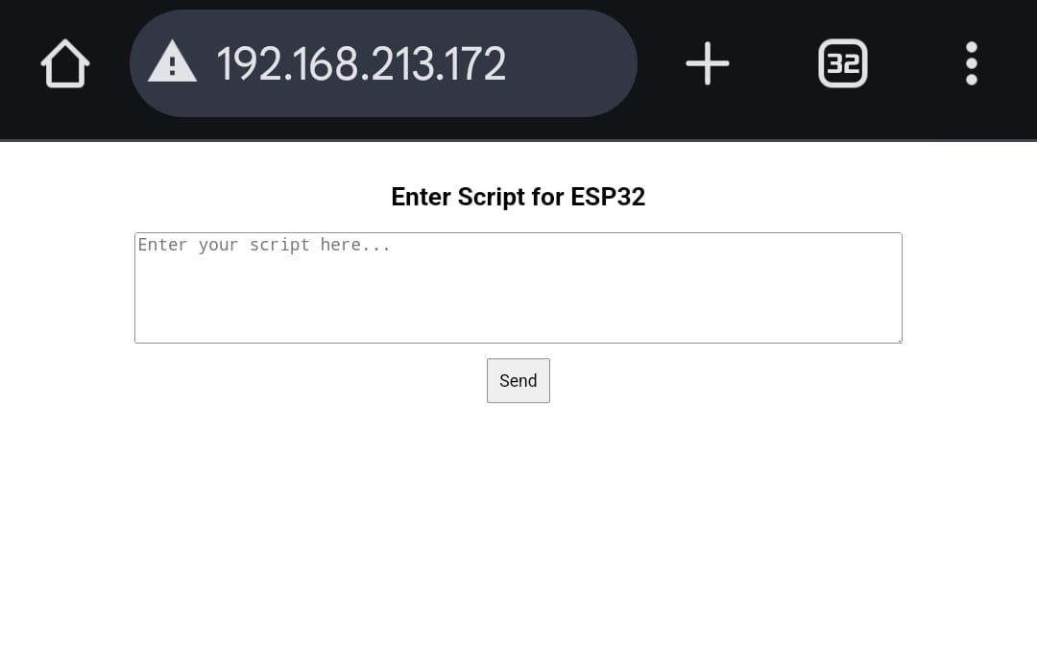

Web servers operate on the Hypertext Transfer Protocol (HTTP), which is the foundation of data communication on the World Wide Web. When you enter a website's URL into your browser, it sends an HTTP request to the web server hosting that website, which then sends back the web page you requested, allowing you to view it in your browser.

13.2 Web Server Architecture
Web server architecture refers to the structure and design of web servers, outlining how they handle incoming requests and deliver web content. There are two main approaches to web server architecture:

Single-Tier (Single Server) Architecture:

In a single-tier architecture, a single server is responsible for both processing requests and serving web content. This is suitable for small websites or applications with low traffic. However, it has limitations in terms of scalability and fault tolerance. If the server goes down, the entire service becomes unavailable.

Multi-Tier (Load-Balanced) Architecture:
In a multi-tier architecture, multiple servers are used to distribute the workload and ensure high availability. This approach often involves load balancers that evenly distribute incoming requests across a cluster of web servers. Each server can serve web content independently, and if one server fails, the load balancer redirects traffic to healthy servers, ensuring uninterrupted service.

13.3 Working of Web Servers
A web server works in the following ways:

Obtain the IP address from domain name: IP address is obtained in two ways either by searchin it in the cache or requesting DNS Servers
Requests full URL from Browsers: After fetching IP address a full URL is demanded from from web server
Web Server Responds to the request: In accordance with the request a response is sent by the server in case of successful request otherwise appropriate error message is sent
The Web Page is displayed on the browser: After getting the response from the server, the web browser displays the result

13.4 Types of Web Servers Softwares:
There are several types of web servers, each designed for specific purposes:

a. Apache HTTP Server : Apache is one of the most popular open-source web servers globally, known for its flexibility and robustness. It's highly customizable and supports a wide range of modules and extensions.

b. Nginx : Nginx is another widely used web server known for its speed and efficiency in handling concurrent connections.

c. Microsoft Internet Information Services (IIS) : IIS is a web server developed by Microsoft for Windows servers. It's commonly used for hosting websites and web applications built on Microsoft technologies like ASP.NET.

d. LiteSpeed : LiteSpeed is a commercial web server known for its high performance and security features. It's often used in hosting environments where speed and security are paramount.

13.5 Features of Web Servers
Web servers offer a range of features, including:

Content Hosting : They store and serve web content, including HTML pages, images, videos, and other multimedia files.
Security : Web servers implement various security mechanisms to protect against unauthorized access and cyberattacks.
Load Balancing : Some web servers can distribute incoming traffic across multiple server instances to ensure optimal performance and availability.
Logging and Monitoring : They provide tools to track and analyze server performance, user access, and error logs.
Caching : Web servers can cache frequently accessed content to reduce server load and improve response times.
13.6 Benefits of Web Servers
Using web servers offers several advantages, including:

Scalability : Web servers can handle a large number of simultaneous connections, making them suitable for high-traffic websites.
Reliability : They are designed for continuous operation and can recover from failures gracefully.
Security : Web servers include security features to protect against common web threats like DDoS attacks and SQL injection.
Customization : Web server configurations can be tailored to specific application requirements.

13.6 Uses of Web Server:
Hosting Websites: The most common use of web servers is to host websites, making them accessible on the internet.
Web Applications: Web servers provide the infrastructure for hosting web applications, enabling users to interact with software through a web interface.
File Sharing: Some web servers are used for file sharing and collaboration, allowing users to upload and download files securely.
Content Delivery: Content delivery networks (CDNs) use web servers to distribute content like images and videos to users worldwide, reducing load times.
API Hosting: Web servers are used to host APIs (Application Programming Interfaces) that allow applications to communicate and exchange data over the internet.

13.8 Conclusion
Web servers are the backbone of the internet, enabling us to access and interact with websites and web applications every day. Understanding their working and architecture is essential for web developers, administrators, and anyone interested in the digital world. Whether you're running a personal blog or managing a complex e-commerce platform, web servers play a pivotal role in delivering online content efficiently and securely.

13. Final Program Block Code
13.1 Program Code

#include "Arduino.h"
#include "USB.h"
#include "USBHIDKeyboard.h"
#include <WiFi.h>
#include <WebServer.h>

const char* ssid = "esp32_server";
const char* password = "esp32_server";

USBHIDKeyboard Keyboard;
WebServer server(80);
String receivedScript = "";

const char index_html[] PROGMEM = R"rawliteral(
<!DOCTYPE html>
<html>
<head>
<title>ESP32 Web Input</title>
<style>
body { font-family: Arial, sans-serif; text-align: center; margin: 40px; }
textarea { width: 80%; height: 100px; font-size: 16px; }
button { padding: 10px; font-size: 16px; margin-top: 10px; }
</style>
</head>
<body>
<h2>Enter Script for ESP32</h2>
<textarea id="scriptInput" placeholder="Enter your script here..."></textarea><br>
<button onclick="sendData()">Send</button>
<p id="response"></p>

<script>
function sendData() {
var scriptText = document.getElementById("scriptInput").value;
fetch("/submit?script=" + encodeURIComponent(scriptText))
.then(response => response.text())
.then(data => document.getElementById("response").innerText = "ESP32 Received: " + data);
}
</script>
</body>
</html>
)rawliteral";

void handleRoot() {
server.send(200, "text/html", index_html);
}

void handleInput() {
if (server.hasArg("script")) {
receivedScript = server.arg("script");
Serial.println("[HTTP] Received Script: " + receivedScript);
server.send(200, "text/plain", "ESP32 Executing Script: " + receivedScript);
executeScript();
} else {
Serial.println("[HTTP] No script received");
server.send(400, "text/plain", "No script received");
}
}

void executeScript() {
Serial.println("[KEYBOARD] Opening Run Dialog...");
Keyboard.press(KEY_LEFT_GUI);
Keyboard.press('r');
Keyboard.releaseAll();
delay(500);

Serial.println("[KEYBOARD] Opening PowerShell...");
Keyboard.println("powershell");
delay(500);
Keyboard.press(KEY_RETURN);
Keyboard.releaseAll();
delay(1000);

if (receivedScript.length() > 0) {
Serial.print("[KEYBOARD] Executing script: ");
Serial.println(receivedScript);

Keyboard.println(receivedScript);
delay(500);
Keyboard.println("powershell -WindowStyle Hidden");
Keyboard.press(KEY_RETURN);
Keyboard.releaseAll();
} else {
Serial.println("[ERROR] No script received. Skipping execution.");
}
}

void setup() {
USB.begin();
Serial.begin(115200);
while (!Serial);
Serial.println("\n[SETUP] Starting ESP32...");

WiFi.begin(ssid, password);
while (WiFi.status() != WL_CONNECTED) {
delay(1000);
Serial.print(".");
}
Serial.println("\n[SETUP] Connected to Wi-Fi!");
Serial.print("[SETUP] ESP32 Local IP: ");
Serial.println(WiFi.localIP());

Keyboard.begin();
server.on("/", handleRoot);
server.on("/submit", handleInput);
server.begin();
Serial.println("[SETUP] Web Server Started!");
}

void loop() {
server.handleClient();
delay(10);
}

Code Explanation

4.1 Libraries Used
cpp
CopyEdit
#include "Arduino.h"
#include "USB.h"
#include "USBHIDKeyboard.h"
#include <WiFi.h>
#include <WebServer.h>
- USB.h and USBHIDKeyboard.h – Enable HID (Human Interface Device) keyboard emulation on ESP32-S3 Mini.
- WiFi.h – Manages Wi-Fi connectivity.
- WebServer.h – Handles HTTP server operations for user input via a web page.

4.2 Wi-Fi Configuration
cpp
CopyEdit
const char* ssid = "Riyaa_ekkada";
const char* password = "riyaa__evaru";
- Stores Wi-Fi SSID and password (should be secured or input dynamically for real-world use).

4.3 USB Keyboard and Web Server Setup
cpp
CopyEdit
USBHIDKeyboard Keyboard;
WebServer server(80);
String receivedScript = "";
- USBHIDKeyboard Keyboard; – Creates a virtual keyboard.
- WebServer server(80); – Initializes a web server on port 80.
- String receivedScript = ""; – Stores the script received from the web interface.

4.4 HTML Web Interface
The following HTML, CSS, and JavaScript are stored in index_html[] and served to users when they access the ESP32 via a browser.
cpp
CopyEdit
const char index_html[] PROGMEM = R"rawliteral(
<!DOCTYPE html>
<html>
<head>
<title>ESP32 Web Input</title>
<style>
body { font-family: Arial, sans-serif; text-align: center; margin: 40px; }
textarea { width: 80%; height: 100px; font-size: 16px; }
button { padding: 10px; font-size: 16px; margin-top: 10px; }
</style>
</head>
<body>
<h2>Enter Script for ESP32</h2>
<textarea id="scriptInput" placeholder="Enter your script here..."></textarea><br>
<button onclick="sendData()">Send</button>
<p id="response"></p>

<script>
function sendData() {
var scriptText = document.getElementById("scriptInput").value;
fetch("/submit?script=" + encodeURIComponent(scriptText))
.then(response => response.text())
.then(data => document.getElementById("response").innerText = "ESP32 Received: " + data);
}
</script>
</body>
</html>
)rawliteral";
- A textarea allows users to input a script.
- A button triggers a JavaScript function (sendData()) to send the script to ESP32 via an HTTP GET request.
- The response from ESP32 is displayed to the user.

4.5 Web Server Handling
ESP32 responds to HTTP requests and processes the user’s input.
cpp
CopyEdit
void handleRoot() {
server.send(200, "text/html", index_html);
}
- Serves the HTML page when users visit the ESP32’s IP address.
cpp
CopyEdit
void handleInput() {
if (server.hasArg("script")) {
receivedScript = server.arg("script");
Serial.println("[HTTP] Received Script: " + receivedScript);
server.send(200, "text/plain", "ESP32 Executing Script: " + receivedScript);
executeScript();
} else {
Serial.println("[HTTP] No script received");
server.send(400, "text/plain", "No script received");
}
}
- When the script is submitted, it is stored in receivedScript, printed to the serial monitor, and executed.

4.6 Keystroke Injection
The executeScript() function simulates keyboard input on the connected PC.
cpp
CopyEdit
void executeScript() {
Serial.println("[KEYBOARD] Opening Run Dialog...");
Keyboard.press(KEY_LEFT_GUI);
Keyboard.press('r');
Keyboard.releaseAll();
delay(500);
- Presses Windows + R to open the Run dialog.
cpp
CopyEdit
Serial.println("[KEYBOARD] Opening PowerShell...");
Keyboard.println("powershell");
delay(500);
Keyboard.press(KEY_RETURN);
Keyboard.releaseAll();
delay(1000);
- Types "powershell" and presses Enter to open PowerShell.
cpp
CopyEdit
if (receivedScript.length() > 0) {
Serial.print("[KEYBOARD] Executing script: ");
Serial.println(receivedScript);

Keyboard.println(receivedScript);
delay(500);
Keyboard.println("powershell -WindowStyle Hidden");
Keyboard.press(KEY_RETURN);
Keyboard.releaseAll();
}
}
- Injects the user’s script and attempts to run it in a hidden PowerShell window.

4.7 Setup Function
cpp
CopyEdit
void setup() {
USB.begin();
Serial.begin(115200);
while (!Serial);
Serial.println("\n[SETUP] Starting ESP32...");

WiFi.begin(ssid, password);
while (WiFi.status() != WL_CONNECTED) {
delay(1000);
Serial.print(".");
}
Serial.println("\n[SETUP] Connected to Wi-Fi!");
Serial.print("[SETUP] ESP32 Local IP: ");
Serial.println(WiFi.localIP());

Keyboard.begin();
server.on("/", handleRoot);
server.on("/submit", handleInput);
server.begin();
Serial.println("[SETUP] Web Server Started!");
}
- Initializes USB, Wi-Fi, and Web Server.
- Waits for Wi-Fi connection and displays the ESP32’s local IP address.
- Starts the USB keyboard emulation and web server.

4.8 Loop Function
cpp
CopyEdit
void loop() {
server.handleClient();
delay(10);
}
- Continuously listens for incoming HTTP requests and processes them.

15. Applications

- Penetration testing: Use the keystroke injection system to simulate attacks on devices or systems, helping identify vulnerabilities.

- Security research: Employ the system to research and demonstrate keystroke injection attacks, highlighting potential security risks.

- Assistive technology: Develop custom keystroke injection systems to assist individuals with disabilities, such as those with mobility or dexterity impairments.

- Accessibility testing: Use the system to test device accessibility and identify areas for improvement.

- Interactive installations: Use the system to create interactive installations or exhibits that respond to user input.

- Cybersecurity training: Utilize the keystroke injection system as a training tool for cybersecurity professionals, teaching them how to identify and mitigate keystroke injection attacks.

16. Features

1. Keystroke injection: The ESP32 can simulate keyboard keystrokes on a connected device, allowing for automation of tasks or injection of malicious code.
2. USB HID support: The ESP32 can emulate a USB HID device, such as a keyboard or mouse, allowing it to communicate with devices that support USB HID.
3. Programmable keystrokes: The ESP32 can be programmed to simulate specific keystrokes or sequences of keystrokes, allowing for customization of the project.
4. Timing control: The ESP32 can control the timing of the keystrokes, allowing for precise control over the simulation.
5. Device compatibility: The project can be designed to work with a variety of devices, including computers, smartphones, and tablet
17. Advantages

- Low-cost: The ESP32 module is a cost-effective solution, making the project accessible to a wide range of users.

- Wireless connectivity: The ESP32 module's wireless connectivity capabilities enable remote control and automation.

- Compact design: The project's compact design makes it easy to integrate into various applications.

- Penetration testing: The project enables security professionals to simulate keystroke injection attacks, helping identify vulnerabilities.
- Security research: The project facilitates research on keystroke injection attacks, contributing to the development of more secure systems.

- Improved security awareness: The project raises awareness about keystroke injection attacks, promoting better security practices.

- Assistive technology: The project has potential applications in assistive technology, enhancing accessibility for individuals with disabilities.

- Automation: The project enables automation of repetitive tasks, increasing efficiency and productivity.

- Innovation: The project's flexibility and customizability encourage innovation and creativity.

18. Disadvantages

- Complexity: The project requires knowledge of programming, electronics, and security concepts, which can be challenging for beginners.

- Limited compatibility: The project may not be compatible with all devices or systems, limiting its applicability.

- Dependence on ESP32 module: The project's functionality is heavily dependent on the ESP32 module, which may have limitations or vulnerabilities.

- Potential for misuse: The project's keystroke injection capabilities can be misused for malicious purposes, such as hacking or espionage.

- Security risks: The project may introduce security risks if not properly implemented or configured, potentially compromising sensitive information.

- Time-consuming setup: The project requires a significant amount of time and effort to set up and configure.

- Maintenance requirements: The project requires regular maintenance and updates to ensure continued functionality and security.

- Ethical concerns: The project raises ethical concerns regarding the use of keystroke injection technology, particularly if used for malicious purposes.

- Legal implications: The project may have legal implications, particularly if used for malicious purposes or in violation of applicable laws and regulations.

